SAISHRUTHIKA M
192572154
SIMATS ENGINEERING
ASSESSMENT TOOL 6

COURSE NAME: Artificial Intelligence COURSE CODE: CSA1715
COURSE OUTCOME COVERED

CO2: Experiment search and game-solving techniques such as Greedy Search, A*, CSP, Minimax, and Alpha-Beta pruning with heuristic functions for solving complex AI problems efficiently. (BL3)
Assessment Tool Weightage: 40%

Duration: 1 Hour
QUESTIONS: 3 Total Marks:30

Annexure A
Dry Run Evaluation
Code of Conduct:
I SAISHRUTHIKA M(192572154 (Name / Reg No) certify that this submission is my original work and that I have adhered to the guidelines specified for this assessment.I understand that any violation of academic integrity rules will result in disciplinary action.
Signature of the student:
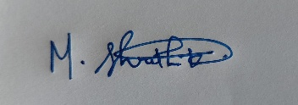

Annexure A

Dry Run Evaluation
1. Question 1 – Breadth-First Search (BFS)
Consider the following graph: A
/ \
B C
/ \ / \
D E F G
Task: Starting from node A, perform a Breadth-First Search (BFS). Complete the following table.
Iteration | Queue | Visited Node
1
2
3
4
5
6
7
Questions:
- Write the BFS traversal order.
- Show the queue contents after each iteration.
2. Depth-First Search (DFS) Using the same graph,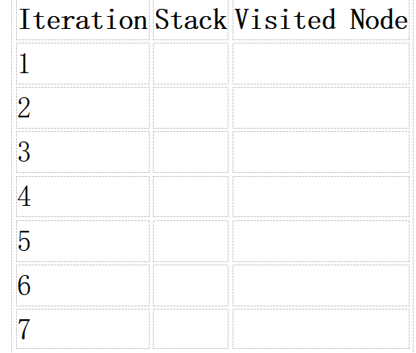
A
/ \
B C
/ \ / \
D E F G
Perform Depth-First Search (DFS) starting from A.
Complete the table.
- Initial State :
1 3 6
5 0 2
4 7 8

Goal State :
1 2 3
4 5 6
7 8 0
Task
Trace Breadth-First Search (BFS) until the goal state is reached.
Fill in the table.
Iteration | Current State | Queue Before Expansion | Queue After Expansion
1
2
3
4
5
Questions
- Which node is expanded in each iteration?
- How many states are generated in total?
- Write the complete solution path from the initial state to the goal state.
- Why does BFS always find the shortest solution in an unweighted 8-puzzle problem?
RUBRICS FOR CALCULATION

Criteria | Weightage (%) | Level 4 – Exemplary (4) | Level 3 – Proficient (3) | Level 2 – Developing (2) | Level 1 – Beginning (1)
Understanding of Search Problem | 20 | Clearly understands the search problem, initial state, goal state, and search strategy. | Understands the problem with minor misunderstandings. | Demonstrates partial understanding of the search problem. | Shows little or no understanding of the search problem.
State Expansion and Dry Run Execution | 30 | Correctly traces every iteration, expands nodes accurately, and maintains the Queue/Stack/Priority Queue without errors. | Performs most iterations correctly with minor mistakes in state expansion or data structure updates. | Performs only some iterations correctly; several errors in tracing or node expansion. | Unable to correctly perform the dry run or expand states.
Application of Search Algorithm | 20 | Applies the selected algorithm (BFS/DFS/UCS) correctly, following all algorithmic rules. | Applies the algorithm correctly with a few procedural errors. | Applies only basic algorithm steps with noticeable mistakes. | Fails to apply the correct search algorithm.
Accuracy of Solution Path | 20 | Identifies the correct traversal order/solution path and goal state with proper justification. | Solution path is mostly correct with minor errors. | Partially correct solution path; goal may not be reached correctly. | Incorrect or incomplete solution path.
Presentation and Logical Reasoning | 10 | Queue/Stack/Priority Queue updates, state diagrams, and explanations are neat, organized, and logically presented. | Presentation is clear with minor organizational issues. | Limited explanation and organization; reasoning is partially clear. | Poor presentation with unclear or missing reasoning.

Criteria | Weightage | Q1 (10) | Q2 (10) | Q3 (10) | Total Marks (30)
Understanding of Problem Context | 20% (2) | /2 | /2 | /2 | /6
Application of Concepts | 30% (3) | /3 | /3 | /3 | /9
Problem-Solving Approach | 20% (2) | /2 | /2 | /2 | /6
Accuracy of Solution | 20% (2) | /2 | /2 | /2 | /6
Clarity | 10% (1) | /1 | /1 | /1 | /3
Total per Question | 10 Marks | /10 | /10 | /10 | /30

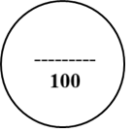

1. Breadth-First Search (BFS)
Algorithm
Input: Graph $G\left(V , E\right)$, Start node $A$
Output: BFS Traversal
- Create an empty queue Q.
- Mark all vertices as unvisited.
- Mark the start node as visited and enqueue it.
- Repeat until the queue becomes empty:
  - Remove the front node from the queue.
  - Visit the node.
  - Add all its unvisited adjacent nodes to the queue.
- End.

Working
Breadth-First Search explores the graph level by level. It first visits the source node, then all of its immediate neighbours, followed by the neighbours of those nodes. A queue (FIFO) is used to maintain the order of traversal.

Steps
Graph
A
/ \
B C
/ \ / \
D E F G
Step 1
Queue = [A]
Visit A
Add B, C
Queue = [B, C]

Step 2
Visit B
Add D, E
Queue = [C, D, E]

Step 3
Visit C
Add F, G
Queue = [D, E, F, G]

Step 4
Visit D
Queue = [E, F, G]

Step 5
Visit E
Queue = [F, G]

Step 6
Visit F
Queue = [G]

Step 7
Visit G
Queue = [ ]

Traversal
BFS Traversal
A → B → C → D → E → F → G

2. Depth-First Search (DFS)
Algorithm
Input: Graph $G\left(V , E\right)$, Start node $A$
Output: DFS Traversal
- Mark all vertices as unvisited.
- Visit the starting node.
- Mark it as visited.
- Recursively visit the first unvisited adjacent node.
- Continue until no adjacent nodes remain.
- Backtrack and continue visiting remaining unvisited nodes.

Working
Depth-First Search explores one branch completely before moving to another branch. It uses recursion (or a stack) to remember the path while backtracking.

Steps
Step 1
Visit A

Step 2
Visit B

Step 3
Visit D
Backtrack to B

Step 4
Visit E
Backtrack to A

Step 5
Visit C

Step 6
Visit F
Backtrack to C

Step 7
Visit G

Traversal
DFS Traversal
A → B → D → E → C → F → G

3. Breadth-First Search for 8-Puzzle
Algorithm
Input
Initial State
1 3 6
5 0 2
4 7 8
Goal State
1 2 3
4 5 6
7 8 0
Output
Shortest sequence of moves.
Algorithm
- Create an empty queue.
- Insert the initial state into the queue.
- Mark the state as visited.
- Repeat until the queue is empty:
  - Remove the first state.
  - If it is the goal state, stop.
  - Generate all valid child states by moving the blank tile.
  - Add unvisited child states to the queue.
- Return the shortest path.

Working
The 8-puzzle is treated as a state-space search problem. Every board configuration is considered a node. BFS expands states level by level using a queue until it reaches the goal state. Since all moves have equal cost, BFS always returns the shortest solution.

Steps
Step 1
Insert Initial State into Queue.
1 3 6
5 0 2
4 7 8

Step 2
Remove first state.
Generate all possible moves of the blank (↑ ↓ ← →).

Step 3
Insert all new states into the queue.

Step 4
Expand the next state in the queue.
Repeat generating successor states.

Step 5
Continue until the goal state is found.
1 2 3
4 5 6
7 8 0

Traversal
Traversal occurs level by level in the state-space tree.
Initial State
│
Level 1 (All possible moves)
│
Level 2
│
Level 3
│
...
│
Goal State

